**PDP Project Report**

**Team:** B1-28

**Members:**

Ramkumar R - COE19B001

S.Karthikeyan - EDM19B001

Adithya R - EDM19B007

Kurapati Chaitanya - EDM19B034

**Project:** Iot Based Power Efficient Surveillance System

**Content:**

* Introduction
* Problem Statement
* Product Design
* Product Functioning / Working Process
* Product Architecture
* Further Enhancements
* Advantages
* Prototype
* Future Updates and improvements
* Conclusion

**Introduction:**

The main purpose of this project is to study about IOT based Surveillance System and to implement it practically.IOT(internet of things ) is mainly used to describe a specific objects or group of such objects with sensors,processing ability ,software and other technologies that connect and exchange data with other devices and systems over the internet or other communication networks.

Internet of things is also considered as as a misnomer because device need not be connected to the public internet ,they just need to be connected to a network and be individually addressable .

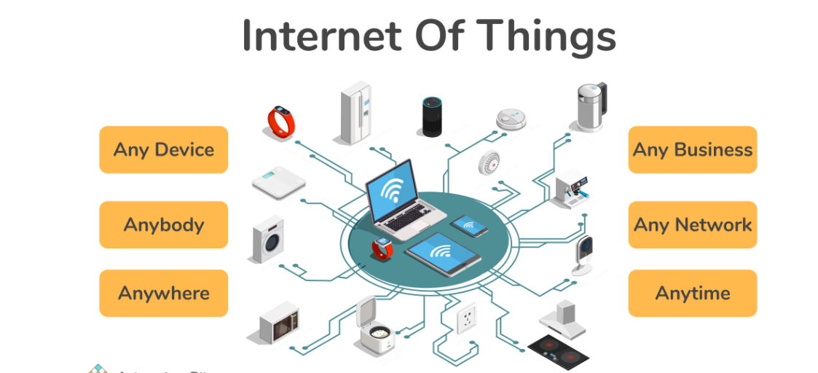

The above image clearly shows us about the flexibility that IOT provides to the users

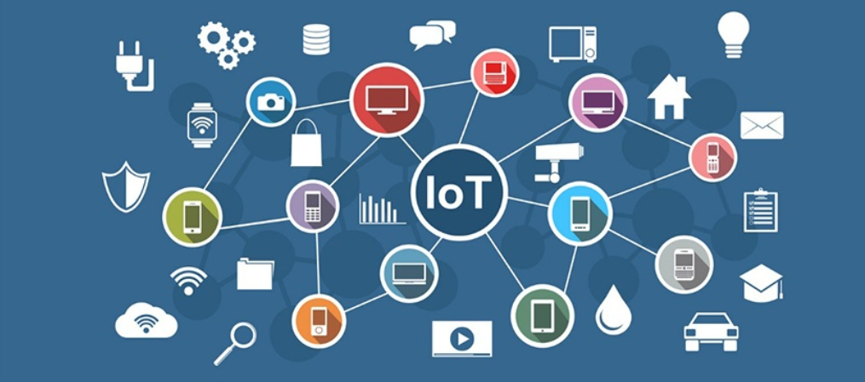

The above clearly shows how IOT helps in connecting all the possible devices without any difficulty

**Problem Statement:**

In the modern world, security is really important and it has become a necessity. The general CCTV surveillance system is tough to install and requires a large amount of data cables to transfer data.

The CCTV records a large amount of data, this includes data which will not be used and requires large storage and complex control application to drive the camera.

**Solution:**

Therefore we have come up with a simple power efficient solution. The Power efficient surveillance system consumes very less power and can be implemented in industrial enterprises as well as individual households.

The system captures images of the surroundings when it senses an object in its range, it then saves the captured images in SD Card locally and uploads the image to cloud storage from where it can be accessed from anywhere.

**User Interest and Requirement:**

Ever since digitization take over the world in the past 10 years everything from a simple electricity bill to important document such as property document has come in online so it is essential that there exists some kind of protection to prevent hackers from misusing it .Thus people around the world prefer security such as voice recognition,face recognition .

Luckily IOT provides all such features which really helps people to keep their data sound and safe and most importantly prevents hackers from misusing it

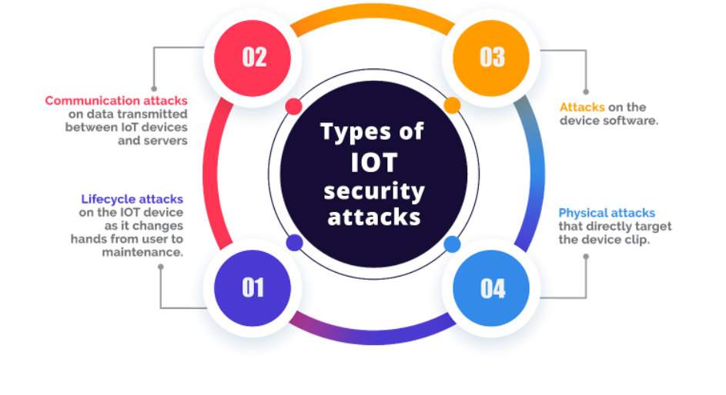

The above image shows the kind of threats that are possible and how IOT helps in preventing all of these attacks



The above images show how IOT provides protection against different kind of external attacks .

**Power Efficiency and Iot:**

A normal CCTV camera consumes on an average of 60GB per day and this huge amount of data and to maintain such a system it is very much expensive .Whereas an IOT device consumes around 20GB per day which is very much cheap and less expensive as compared to normal surveillance system .

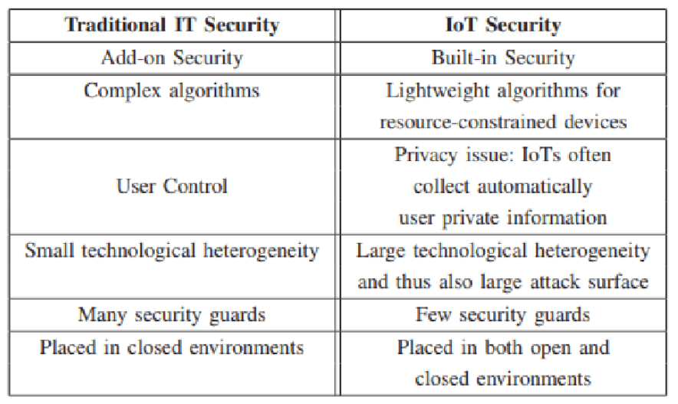

The above tabular column clearly explains the power and advantages of iot security compared to normal security

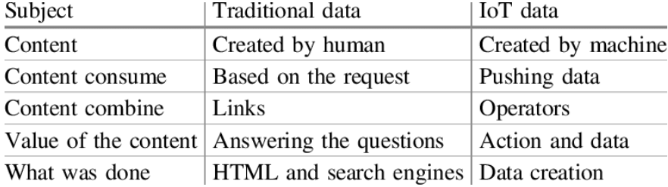

Further important differences between the traditional and IOT security and data

**Individual Roles and Contribution:**

* Ramkumar has worked on database logging program for images, the ESP32 CAM once triggered will take an Image and log it into the firebase database, from where the user can view it.
* Karthikeyan has worked on the front end of the webpage as well as the client side javascript program to view the Images from the database, access images and other files. He has worked on the wireless Interface between the two MCUs and HTTP.
* Adithya has worked on the final circuit design layout for the product, he has worked on hardware interfacing for I2C LCD, ultrasonic sensor and protocols associated with ESP32 and ESP32 CAM.
* Chaitanya has worked on the main program that initializes the hardware such as camera, SD card, sensor and the image capture part of the program. He has worked on debugging the firmware and interfacing hardware with desired features.

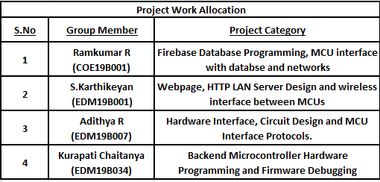

**Product Functioning:**

The IoT based microcontroller stays in idle state until a wake signal is given. Then the microcontroller monitors the area with the help of an ultrasonic sensor. The microcontroller also checks the surrounding temperature, sound and fire to keep check of things happening around it.

If any object is detected in a particular range, which will be set depending upon the physical surrounding of the microcontroller, it alerts and uses the camera module to capture the image.

It then transfers the captured image to the web server, from where the user will be able to see if there was any potential security threat. In order to alert the user to take action immediately it can send a message to the user's smartphone, from where the user will understand the alert and proceeds to check the web server for pictures and more details.

We have employed two microcontrollers which communicate between each other, these can be considered as two subsystems of the main system. One is ESP32 and the other one is ESP32 CAM Module.

The ESP32 module is interfaced with LCD, Buzzer and Ultrasonic Sensor. This module primarily performs the function of sensing and monitoring the surroundings..

If the ESP32 Senses any object in the allotted range it triggers the buzzer and sends a wireless HTTP request to the main ESP32 CAM Module.

Hardware Interface and Circuit Design:

* This part includes the hardware interfacing like LCD, Camera module, Sensors, micro SD card etc.
* The circuit design involves the designing of the circuit layout and implementing it. The LCD connects to I2C pins of ESP32 microcontroller.
* Sensors and other peripherals are connected to GPIOs. The GPIO layout and alternate functionality of pins are given below.

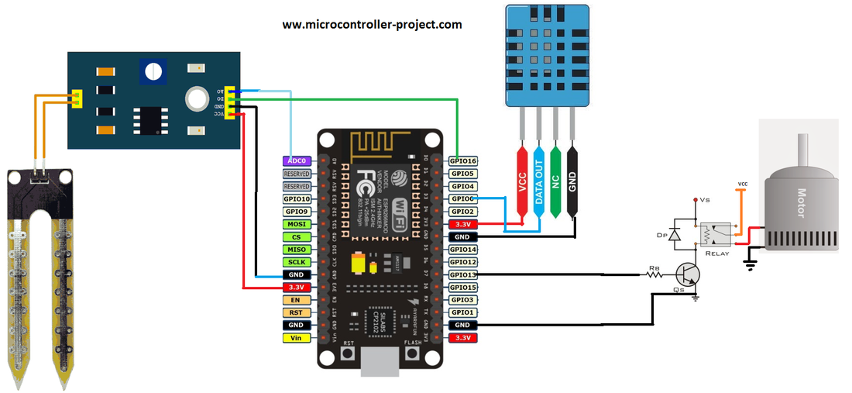

Webpage and HTTP LAN Server Design:

* This part involves designing the front end and backend for the HTTP server that will be hosted on the LAN. This server can be accessed by any device connected to LAN.
* The front end will be designed using HTML and JS and will be styled using CSS. These program files will be stored in a microcontroller and will be sent to the client on request.
* The backend will be done using arduino language and ESPAsyncWebServer and AsyncTCP libraries. The front end files will also be stored using SPIFFS library (SPI Flash File System).

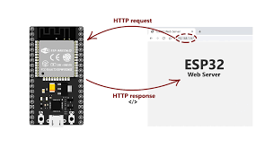

Firebase Database Programming:

* This part involves the programming implemented to log data into a database. This data can be accessed from anywhere using the internet.
* The data logging is done using Web APIs, the sensor readings and data are logged into Real Time Database (RTDB).
* The images captured are logged into Firebase Storage. The programming is done using arduino language and Firebase libraries

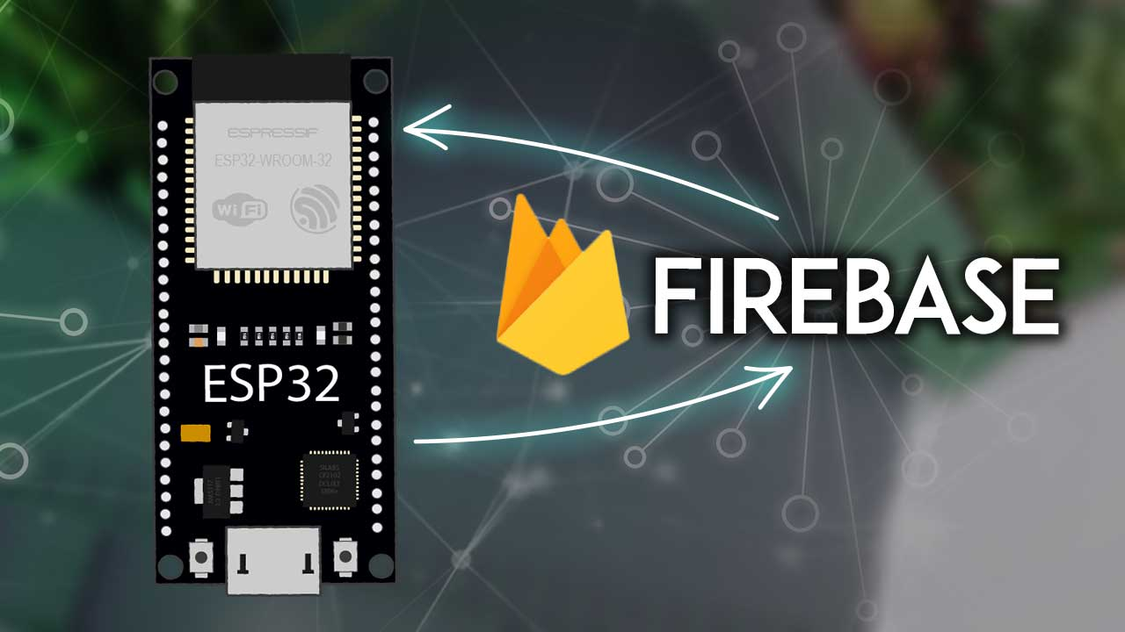

Backend Microcontroller Hardware Programming:

* This part involves the hardware part of the programming. The Iot part is covered completely in the above two sections.
* Here we program the MCU to interact with the interfaced hardware like LCD, Camera module, Ultrasonic Sensor and communicate with other MCU using UART/I2C/SPI protocols
* This part is carried out using the arduino framework for ESP32. The arduino libraries are used for related protocols and features.

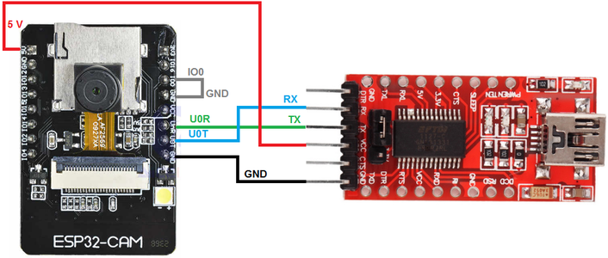

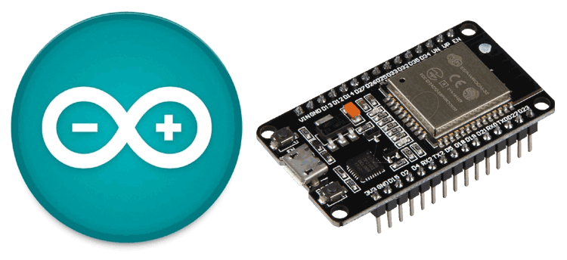

**Product Architecture:**

* In our product we will be using a core IoT microcontroller. This microcontroller will act as the brain of our project and will be responsible for sending data through the internet as well as interacting with the various sensors and peripherals.
* As for the microcontroller we will be going for ESP32 from espressif systems. We will be using an ultrasonic sensor and camera module to monitor the area.
* Our product will be used in a wide variety of surroundings from individual houses to industrial enterprises. In that situation it is necessary for our product to sense the surrounding situation continuously, this will help the machine understand the type

of the environment it is working.

* The general **block diagram** of the overall system is shown below.

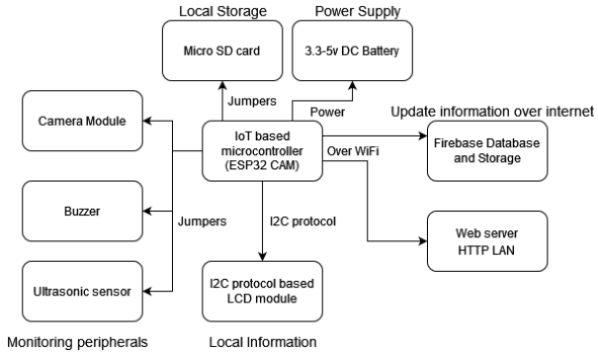

**Prototype**

* The prototype has been designed after the procurement of the individual components.
* The Updated **Bill of Materials** is given below:

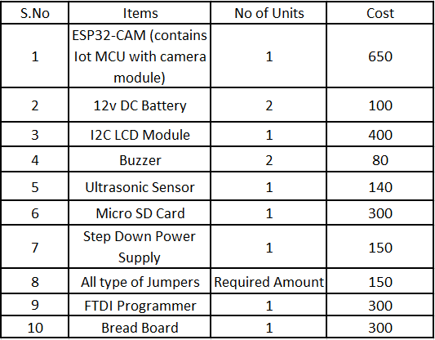

* The Systems which were designed are implemented in the prototype.
* The Systems include Monitoring System, Capturing System and the power Supply System.
* The Prototype Images are showcased below.

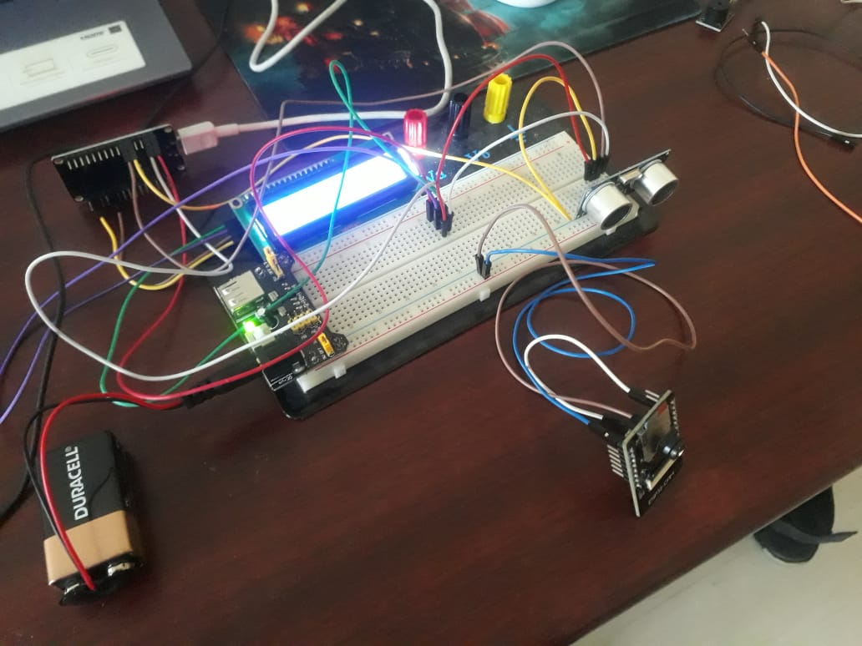

Overall System

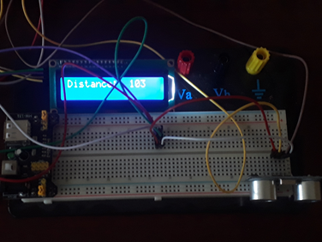

LCD and Ultrasonic Sensor Modules

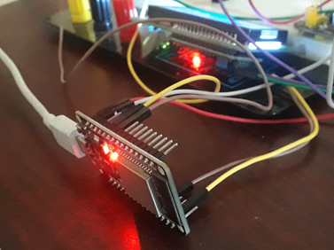

ESP32 Monitoring Module

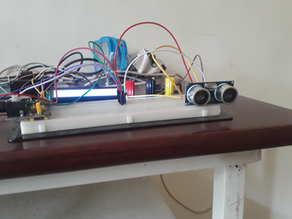

Side View

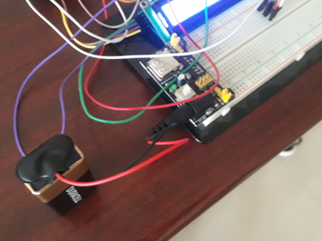

Power Supply Module

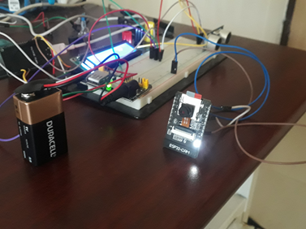

Capturing Module ESP32 CAM

**Future Updates and improvements**

The product has vast scope for improvement in the future.The ways where the prototype can be improved are:

* Ultrasonic Sensor Range, more powerful ultrasonic sensor can be employed which has better range. Therefore the trigger slot can be set far away from the system
* Using a separate Camera Module, with realtime feed Display if prompted by the user with a more advanced Micro controller
* Using ML and DL algorithms for Human detection , facial recognition to verify possible break ins
* Synchronizing the use of multiple Ultrasonic Sensors , Multiple camera modules
* Creating a security system rather than a surveillance system with biometric scans etc.

**Conclusion:**

* We can bring down the crime rates and implement better surveillance to public areas, individual houses and industrial complexes.
* Our system will be better adaptable to surroundings and perform its task efficiently as compared to CCTV, it need not be wired and it can log the data to web servers and can use the internet as a medium to perform all activities.
* It can be the future monitoring device across places which works on the basis of IOT.

**Results:**

* The Surveillance System has been implemented successfully and the results observed from the system are showcased below

**ESP32 CAM Functioning and Webpage**

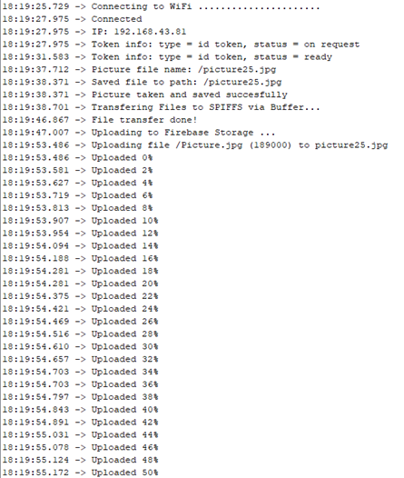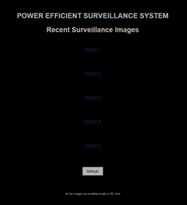

**Webpage Link:** <https://esp-firebase-demo-b12e9.web.app/>

**ESP32 CAM Debugger**

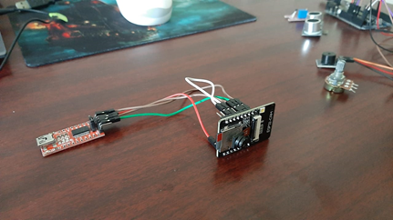

**Surveillance Images**

